Plug the 5v mini USB power supply into the port marked PWR. Connect the owl to a computer via the port marked OTG. Wait approximately one minute for the owl to boot up before proceeding.

Type into windows search “view network status and tasks”, and click the icon licking to the control panel.

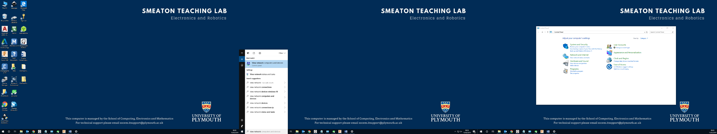

Click on the link called “Change adapter settings”



Look for an adapter called “USB Ethernet/RNDIS Gadget”. If you do not see this, try refreshing the window, or restarting the owl. Otherwise, right click the adapter and select properties.



Select “Internet Protocol Version 4” from the list of options, then click properties.



Select the option “Use the following IP address” and enter the details as shown in the image below.



If a window pops up titled “Microsoft TCP/IP”, click No.

Open PuTTY, and select the connection type “SSH”. Set the IP address as 10.0.0.10, and leave the port as 22. A window may pop up the first time you connect, just click “Yes”. Then enter “pi” as the user name and “raspberry” as the password.

Wait a few seconds for the terminal to log you in, before hitting the up arrow untill you see the command “./OWLsocket”. This code must be running for the computer to communicate to the owls motors. It will exit each time you finish running your code so make sure to restart it each time.

When packing away the owl, make sure to shut it down safely by using the shutdown command (it can be found by pressing up through the most recent commands)

Make sure to remember your owl number, and use the same one every week (as the calibration you do will only work on your owl). Also use the same computer and USB port, so that you don’t have to do this setup again